# Assignment 3

|  |  |
| --- | --- |
| Assignment Date | 28 September 2022 |
| Student Name | S.Sudheekshan kumar |
| Student Roll Number | 311519104703 |
| Maximum Marks | 2 Marks |

**Question-1:**

Create a Bucket in IBM object storage

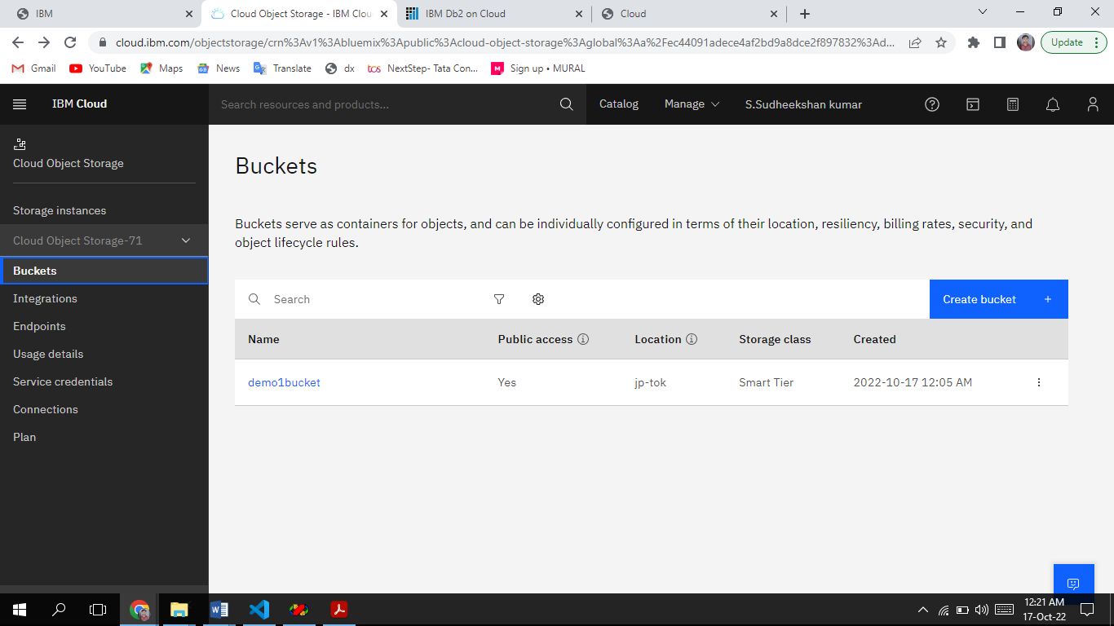

# Question-2:

Upload an 5 images to ibm object storage and make it public. write html code to displaying all the 5 images

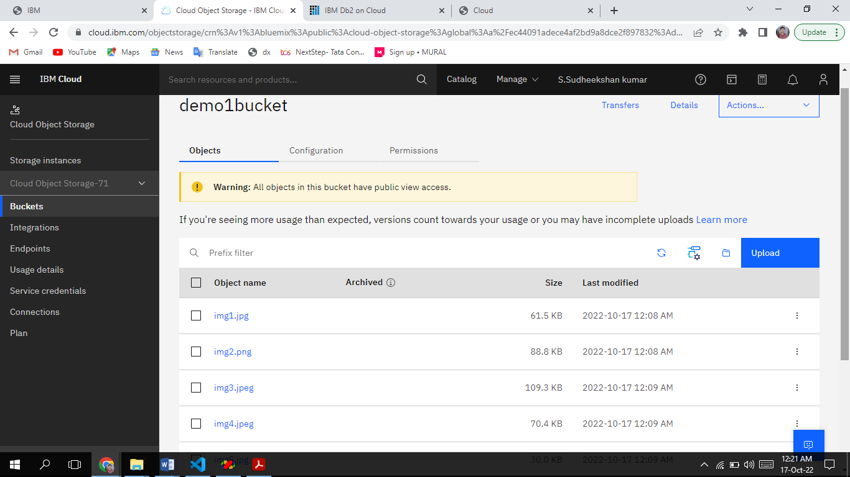

# Question-3:

Upload a css page to the object storage and use the same page in your HTML code

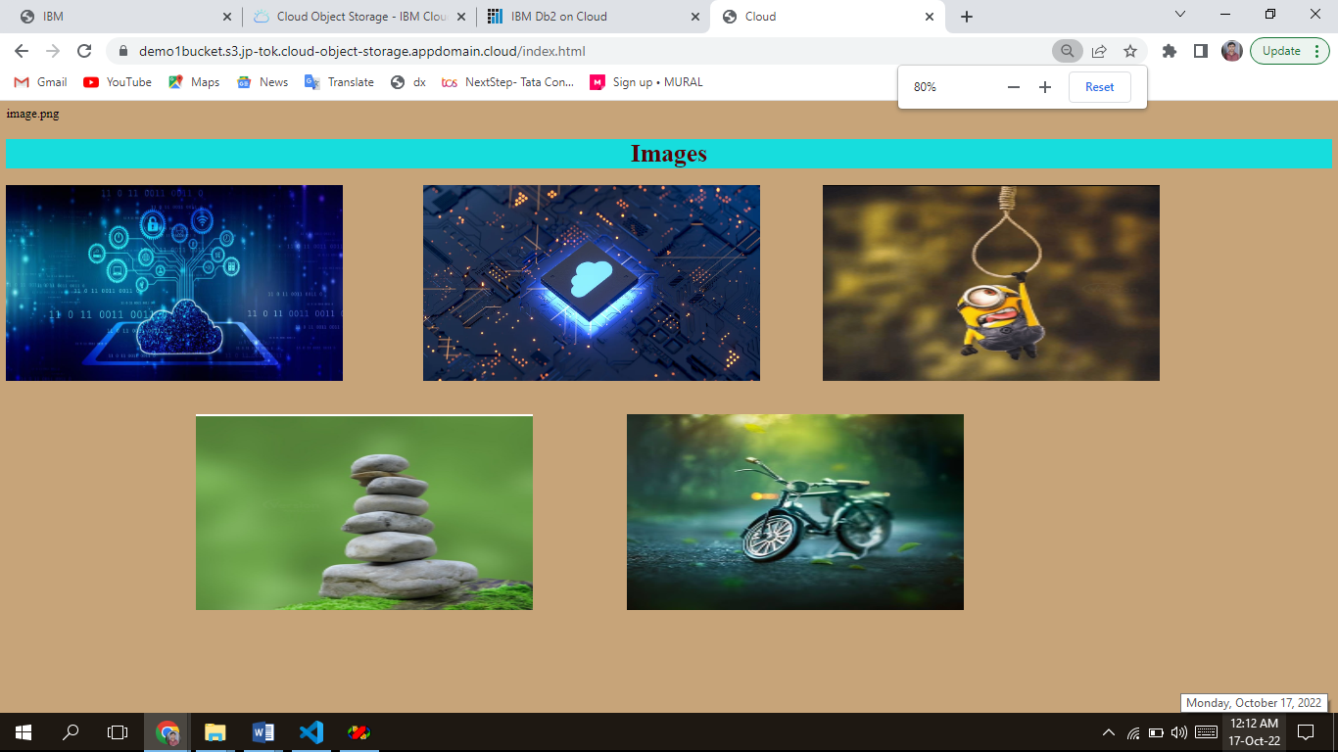

Index.html

<!DOCTYPE html>

<html lang="en">

<head>

<meta charset="UTF-8">

<meta http-equiv="X-UA-Compatible" content="IE=edge">

<meta name="viewport" content="width=device-width, initial-scale=1.0">

<title>Cloud</title>

<link rel="stylesheet" href="style.css">

</head>

<body>

<center><h1>Cloud Computing</h1></center>

<img id="img1" src="ibm_01.jpg" alt=""width="430" height="250">

<img id="img2" style="left: 540px;"src="ibm_02.jpg" alt=""width="430" height="250">

<img id="img3" style="left: 1050px;"src="ibm_03.jpg" alt=""width="430" height="250">

<img id="img4" style="top:400px;left: 250px;"src="ibm_04.jpg" alt=""width="430" height="250">

<img id="img5" style="top:400px;left: 800px;"src="ibm_05.jpg" alt=""width="430" height="250">

</body>

</html> Style.css

body

{

background-color: black;

}

h1

{

color: darkblue; background-color: white;

}

img

{

position: absolute;

}

# Question-4:

Design a chatbot using IBM Watson assistant for hospital. Ex: User comes with query to know the branches for that hospital in your city. Submit the web URL of that chat bot as a assignment

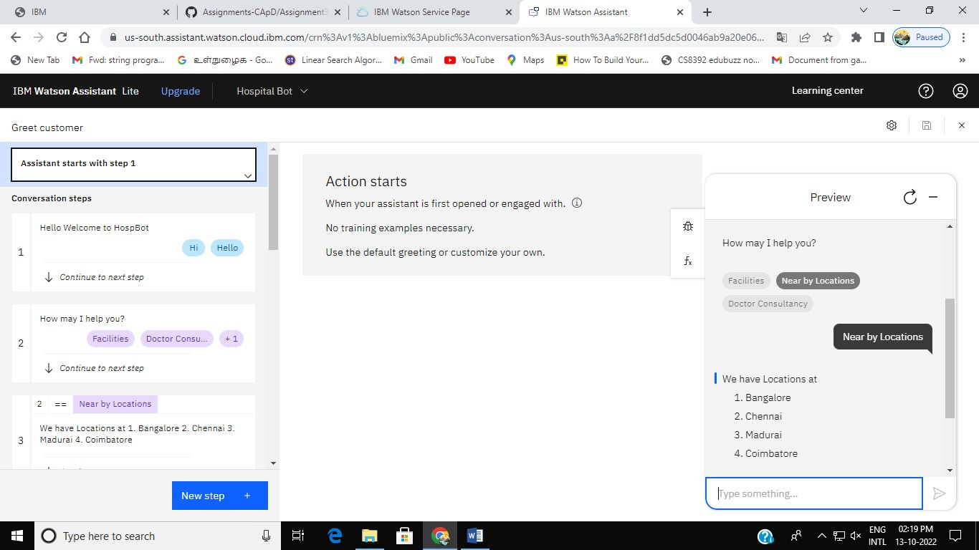

# Question-5:

Create Watson assistant service with 10 steps and use 3 conditions in it. Load that script in HTML page

